**ASSIGNMENT 1**

|  |  |
| --- | --- |
| Project Name | Personal Expense Tracker Application |
| Team Id | PNT2022TMID50562 |
| Student Name | Praveen A |
| Student Roll Number | 952819104040 |

**Code:**

<https://github.com/IBM-EPBL/IBM-Project-47799-1660802348/tree/main/Assignments>

**Instruction 1:**

Create a registration page in HTML with username, email, and phone number, and by using the POST method display it on the next HTML page.

**Output:**

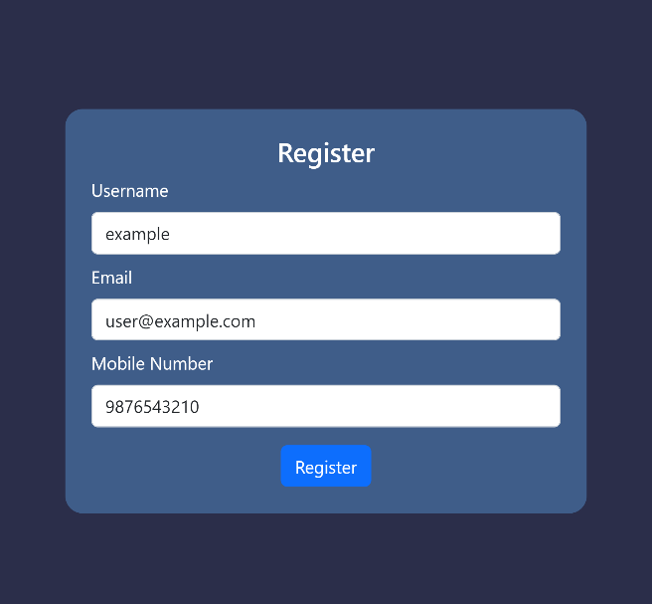 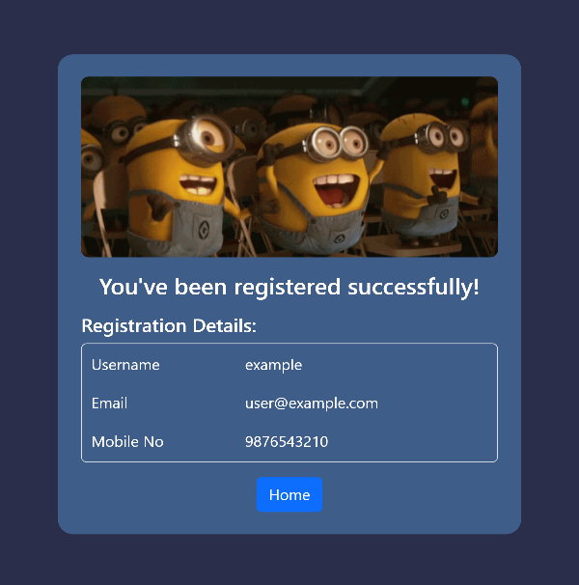

**Instruction 2:**

Develop a flask program which should contain at least 5 packages used from pypi.org.

**Output:**

1. Flask

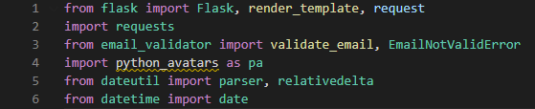

1. Age Calculator

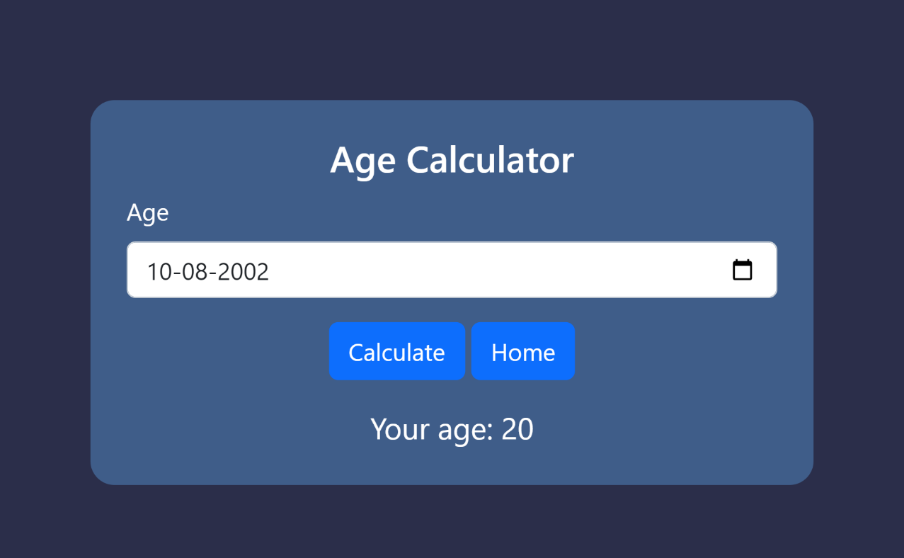

1. Random Avator Generator

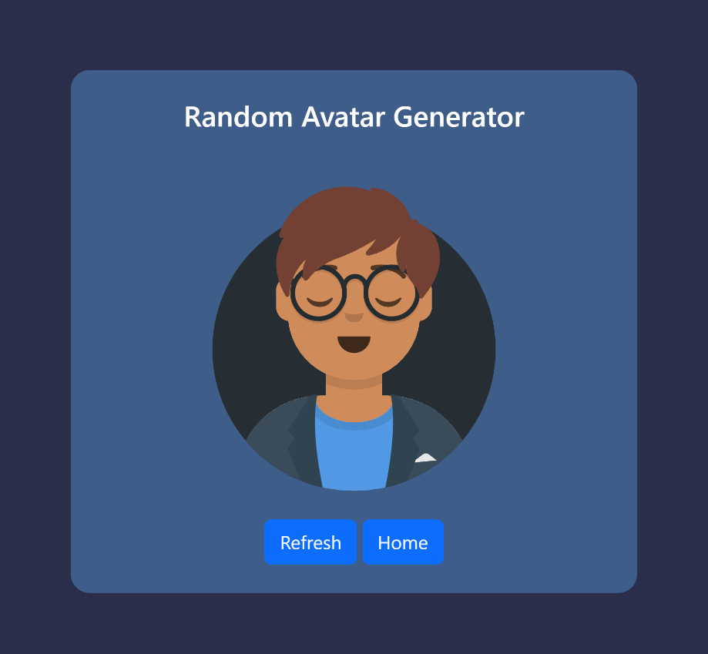

1. Site Working Status

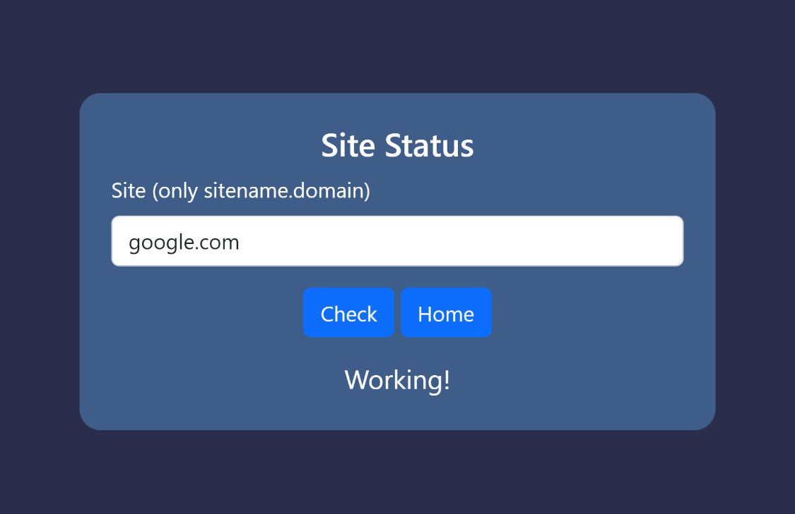

1. Email Validator

